

Software Requirements Specification

(short form) for

**Premium Customer Services (PCS) 2.5**

Tracking#: PR_4292

Version: 0.08

Issued: July 22, 2014

Arleen Anderson

This material is the exclusive property of, and confidential to, Syniverse Technologies, LLC. Any disclosure or reproduction of this material without Syniverse’s express prior written consent is strictly prohibited.

The following product and service names, and the Syniverse name and logo are services, software products, service marks and/or trademarks of Syniverse Technologies, LLC.

|  |  |
| --- | --- |
| ACCESS® | IVDRS® |
| ACCESS S&E® | LATALink® |
| ACCESSibility® | Syniverse® |
| CrossroadsSM | Syniverse MORE® |
| FMR Plus® | SyniverseNEXT® |
| Follow Me Roaming Plus® | Syniverse PRIME® |
| FraudInterceptor® | Syniverse Technologies® & spark design |
| FraudManager® | UniRoam® |
| FraudX® | Visibility® |
| INLink® | VisWise® |
| INPort® | We Make Mobile Work® |

Netscape and Netscape Communicator are registered trademarks of Netscape Communications Corporation.  
Microsoft and Windows are registered trademarks of Microsoft Corporation.  
Office and BackOffice are trademarks of Microsoft Corporation.

Used by Permission.

As used herein, ® denotes registration in the United States.

© Copyright 2001 ─ 2014 Syniverse Technologies, LLC  
All rights reserved under U.S. and International laws.

The document is based on SRS Template (short form) Version 4.13 (August 2013)

**Revision History**

|  |  |  |
| --- | --- | --- |
| **Version** | **Date** | **Release Reason - Description of Changes** |
| 0.08 | 22 July 2014 | * 3.1.2.2 – changed last session to last completed session * 3.2.2.1.1 – removed the following:   + Current Active Session   + Last Session Start Time   + Last Session End Time   + Successful?   + Failure Reason   And added the following:   * Last Session Attempt Successful? * Last Session Attempt Failure Reason * Last Session Attempt Start Time * Last Session Attempt Network Type * Last Session Attempt Activation Time * 3.2.2.1.2 – changed from recent open session to recent session attempt * 3.2.3 – changed last session to last completed session * 3.2.3.1 – changed last session to last completed session and added the following fields:   + Last Session Attempted     - Succssful?     - Failure Reason     - Session Start Time     - Network Type     - Session Activation Time     - Roaming Country     - Visited Operator     - APN Node     - SGSN   Removed the following:   * Current Active Session * Last Session Start Time * Last Session End Time * Session Activation Time * 3.2.3.1 – modified session status fields * 3.2.3.2 – modified fields * 3.4.1.1 – changed Alert to Action * 3.4.1.1.1 – changed Alert to Action and modified attributes * 3.4.1.1.2 – modified attributes |
| 0.07 | 16 July 2014 | * 3 – added “in regards to QoE” * 3.1.1 – changed from Date to Data (for DPM) * 3.3.1 – added that default is 7 days * Removed 3.3.1.1 and added Start/End date to 3.3.1.2 * 3.3.1.2 – changed names to match GUI * 3.3.1.3 – added default 7 days and aggregation rqmts and removed note * Removed 3.3.2.1 and added Start/End date to 3.3.2.2 * 3.3.2.3 – added default 7 days and aggregation rqmts and removed note * Removed 3.3.3.1 and added Start/End date to 3.3.3.2 * 3.3.3.3 – added default 7 days and aggregation rqmts and removed note * 3.4.1 – added by Subject Area * 3.4.1.1 – changed to group alert and subscriber roaming history and stated to create subject are * 3.4.1.1.1 – changed title to Group Alert History Subject Area Attributes * 3.4.1.1.2 – changed title to Subscriber Roaming History Subject Area Attributes * Added 3.5.1.1.1 – Adding/Using Templates * Added 3.5.1.1.2 – Template Policy Information * Removed 3.5.1.2 – Simple & Advanced Templates * Added 3.8.1 – Left Menu Item * 3.8.2 – added Analyzer PCS Reporting as user level permission * Removed 3.8.2.1 – Permission Control |
| 0.06 | 03 July 2014 | * 3.1.1 – added v1 & v2 * 3.1.2.3 – Data Session Activation Time – changed activate to create and added create session context * Added 3.1.3 – Updating Templates * 3.2.2.1.1 – added create session context and delete session context * Added 3.3.1.1.1 – Group History attributes * Added 3.3.1.1.2 – Subscriber Action History attributes * Added 3.4 – PCS Provisioning GUI * Added 3.5.1.1 – Consecutive Data Session Create failures * Added 3.5.3 – Suppression of Notifications * Added 3.5.4 – Group Status Notification |
| 0.05 | 25 June 2014 |  |
| 0.04 | 17 June 2014 |  |
| 0.03 | 04 June 2014 |  |
| 0.02 | 15 May 2014 | * 3.1.2 – added that the DPM feed will be one feed send every 15 minutes * Removed 3.1.3.1 – Voice OoE parameters * Removed 3.1.3.3 – SMS QoE parameters * New 3.1.3.2 – removed voice and SMS * New 3.1.3.3 – Added that RTI will update the template to accept the threshold value for each OoE KPI. * 3.2.2.1:   + removed SMS, and MT call delivery from customer info   + removed voice and SMS Qoe status   + added “or equal to” after greater than and less than   + Removed references to SMS MO * 3.2.3.1 – removed voice, SMS and overall * 3.3.1 – removed trigger email notification when there are more than X number of SMS MO Failures for an IMSI(s) within a specified time interval * 3.4.1 – removed permissions for Voice and SMS |
| 0.01 | 13 May 2014 | Initial Release |

**Table of Contents**

1 Introduction 6

1.1 Description of the Enhancement Request/Scope 6

1.2 Impacts to Existing Processes 6

1.2.1 Other Considerations: Constraints, Assumptions, Potential Enhancements 6

1.3 Other Impacts/Supplemental Requirements 6

1.4 Definitions, Acronyms, and Abbreviations 8

1.5 Reference Documents 8

1.6 Correction and Revisions 8

2 Overall Description – Background (Reference Section 1.1) 8

3 Feature & Supplemental Requirements 9

3.1 RTI 9

3.1.1 RTI Receives Additional Data Feeds 9

3.1.2 RTI Tracks QoE KPI Data for Monitored IMSIs 9

3.1.3 Updating Templates 11

3.2 PCS GUI 12

3.2.1 Network Level View 12

3.2.2 Service Level View 12

3.2.3 Service Level Summary View Information 13

3.3 Service Level Detail View Information 17

3.3.1 Bandwidth Reports 17

3.3.2 Data Session Context Report 18

3.3.3 Data Session Activation Time Report 19

3.3.4 Reports Based on Search Criteria 19

3.4 Enterprise Reporting 20

3.4.1 Adhoc Reports by Subject Area 20

3.5 PCS Provisioning GUI 21

3.5.1 Multiple Template Policies per Group 21

3.6 Rules Engine 22

3.6.1 Trigger Notifications 22

3.6.2 Rules Template Attributes 23

3.6.3 Suppression of Notifications 24

3.6.4 Group Status Notification 24

3.6.5 Logging, Reporting, and Audits 24

3.7 Billling 25

3.8 Crossroads 26

3.8.1 Left Menu Item 26

3.8.2 User Level Permissions 26

4 Supplemental Requirements: (Reference Section 1.4 and Section 3) 27

5 Requirements Tracing Matrix 27

# Introduction

## Description of the Enhancement Request/Scope

This project is a key element to implement Syniverse RTI strategy to offer innovative solutions to the mobile industry by offering a service that will help tier 1 operators to improve the care and experience of their subscribers. It addresses the needs of Verizon, AT&T, Telcel, and many others.

The Premium Customer Service 2.5 solution will include additional data feeds (GTP-C, Data Performance Monitor /DPM) to track quality of experience metrics. This will allow operators to monitor and track data quality of experience and receive real-time notifications when subscribers experience poor quality of experience.

Also, it will provide the security and usability improvements necessary to help deploy the application to a customer care organization.

## Impacts to Existing Processes

Below are the main objectives of this project:

1. Support additional data feeds (GTP-C, DPM) to report and monitor in real time on QoE metrics within PCS
2. Provide capabilities to perform real-time detection of the subscriber quality of Experiences and trigger actions at the subscriber level
3. Address the requirements of Quality of Experience tracking
4. Provide new UI to track and monitor subscriber Data QoE

This will be incorporated into the current PCS 2.0 product; the target production date is by end of November, 2014.

### Other Considerations: Constraints, Assumptions, Potential Enhancements

#### Assumptions

##### Premium Customer Services shall continue to support the SS7 GSM, UniRoam, and Rev C data feeds currently implemented in production Premium Customer Services 2.1.

##### Premium Customer Services shall continue to support the features of the previous versions unless explicitly stated otherwise.

## Other Impacts/Supplemental Requirements

|  |  |  |
| --- | --- | --- |
| **Ref SRS** | **Supplemental Requirements** | **Impact** |
| 4.1 | *Application GUI Requirements*   1. *User Experience Guidelines* 2. *Use Cases* 3. *Prototyping* 4. *Usability Testing* 5. *Task Flow* 6. *Legacy Applications* |  |
| 4.2 | *Provisioning Requirements*   1. *Enterprise Provisioning Requirements* 2. *Crossroads Requirements* 3. *Data Initialization/Conversion Requirements* 4. *Automated Provisioning Interface requirements* |  |
| 4.3 | *Interface Requirements*   1. *User/System Interface Requirements* 2. *Hardware Interfaces Requirements* 3. *Network Interfaces Requirements* 4. *Software/Communications Interfaces Requirements* |  |
| 4.4 | *Performance Requirements*   1. *Volume and Frequency of Information* 2. *Data Retention Requirements* 3. *Throughput* 4. *Response Times* 5. *Number of Terminals* 6. *Number of Simultaneous Users and User-Concurrent Transactions* 7. *Availability* |  |
| 4.5 | *Enterprise Requirements*   1. *Syniverse Enterprise/Infrastructure* 2. *Disaster Recovery* 3. *Security Requirements & System Access* 4. *Data Privacy* 5. *Internationalization* 6. *Support Multilingual* 7. *Backup and Recovery Controls* 8. *Job Scheduling Controls* 9. *SLA Requirements* 10. *Standard Operational* 11. *Provide Basic Troubleshooting GUI* |  |
| 4.6 | *Billing*   1. *Financial Billing* 2. *Billing Support* 3. *Billing Data Retention* 4. *Billable Elements (aka INVARs)* 5. *Interim Billing Requirements (Pre-Automation)* |  |
| 4.7 | *Revenue Assurance*   1. *Reconcile Production data to summarized Billing data* 2. *Reconcile Production data to other Interfaced Systems (Analyzer & Accessibility)* 3. *Transaction Monitoring & Alarming* |  |
| 4.8 | *Supplemental Reports*   1. *Reports* 2. *Report Validation Requirements* |  |
| 4.9 | *Testing*   1. *Application Testing* 2. *Operational Testing* 3. *Other (UAT, alpha, Beta, etc)* | A System Test Plan based on IEEE standard 829 is required with test scripts and cases. |
| 4.10 | *Documentation and Training*   1. *User Documentation* 2. *User Training* | Training and documentation materials will need to be updated to reflect the new feature. |
| 4.11 | *Internal/Support Requirements*   1. *Auditing* 2. *Application Monitoring/Support Tools* 3. *Network Monitoring/Support Tools* 4. *Customer Support Tools* 5. *Enterprise Provisioning/CTP/Tables Tools* 6. *Training and Documentation Tools* 7. *Test Tools* 8. *Implementation Tools* 9. *Sales Tools* 10. *Internal Documentation (Product Support Plan, Operations OA&M, Implementation)* 11. *Internal Training* |  |

## Definitions, Acronyms, and Abbreviations

| **Acronyms and Abbreviations** | **Description** |
| --- | --- |
| PCS | Premium Customer Services |
| QoE | Quality of Experience |
| RTI | Real Time Intelligence |

## Reference Documents

| **Document Title, Version #, Date** | **Description** |
| --- | --- |
| Approved Business Case or BRD or  Evaluation Document | Provide link if available |
| Data Privacy Office | [Syniverse Data Privacy Office](http://central.syniverse.com/sites/FIN/GRC/DPO/SitePages/Home.aspx?RootFolder=%2Fsites%2FFIN%2FGRC%2FDPO%2FShared%20Documents%2FProgram%20Information&FolderCTID=0x012000095106CCD6435B4EB22DD8103878D1E2&View=%7bF4F369CC-9671-4A4C-99E8-D5C191CD6ABA%7d) |
| Global Security Policies | [Security Policies](http://central.syniverse.com/sites/sec/sec/Security%20Policies/Forms/AllItems.aspx) |
| Global Training &Documentation (GTD)  Request for Training/Documentation | [Global Training &Documentation](http://central.syniverse.com/sites/CUST/pc/train/Shared%20Documents/Forms/AllItems.aspx?InitialTabId=Ribbon%2EDocument&VisibilityContext=WSSTabPersistence) |
| Syniverse Billing Interface File (BIF) Format | [Syniverse Billing Interface File (BIF) Format](http://central.syniverse.com/sites/sec/APPS/BLASR/SitePages/Home.aspx?RootFolder=%2Fsites%2Fsec%2FAPPS%2FBLASR%2FShared%20Documents%2FDocumentation%2FInput%20Files&FolderCTID=0x012000B0DECA26EEFE154FB38C99D1708BA871&View=%7b1F699D7C-AE89-483D-8F63-66FCCB91005C%7d&InitialTabId=Ribbon%2EDocument&VisibilityContext=WSSTabPersistence) |
| User Experience Website | [User experience website](http://central.syniverse.com/sites/TECH/arch/exp/SitePages/Home.aspx) |
| Global Customer Operations Corporate Policies | [Global Customer Operations CorpPolicies](http://central.syniverse.com/sites/CUST/CorpPolicies/Forms/AllItems.aspx) |
| Operations Quality Control Handbook - A Guide to Best Practices | <http://skrcollab.syniverse.com/gm/folder-1.11.61595> |

## Correction and Revisions

This document will evolve as these requirements are reviewed. Please direct comments or suggestions for modification, preferably via email, to:

**Arleen Anderson**

**(813) 414-4288**

[**arleen.anderson@syniverse.com**](mailto:arleen.anderson@syniverse.com)

# Overall Description – Background (Reference Section 1.1)

# Feature & Supplemental Requirements

PCS 2.5 shall have the ability to support Visibility GTPc customers and/or DPM customers in regards to QoE status.

## RTI

### RTI Receives Additional Data Feeds

RTI shall have the ability to receive the following data feeds from Roam Monitor in order to report on QoE metrics within PCS:

* GTPc (v1 & v2) – from Visibility
* Data Performance Monitor (DPM) Data Feed – from Roam Monitor - this is part of the Roam Monitor product that provides the ability to take in-session metrics to provide further visibility into the overall customer experience (e.g. available bandwidth and average throughput). This will be one feed sent every 15 minutes.

*NOTE: See* [*Roam Monitor XDR Specification*](http://central.syniverse.com/sites/TECH/proddev/roam/roammonitor/XDR%20Specification/Forms/AllItems.aspx) *for more information.*

### RTI Tracks QoE KPI Data for Monitored IMSIs

RTI shall have the ability to track the QoE KPI information received in the data feeds for monitored IMSIs.

#### Data QoE Parameters

RTI shall have the ability to track the data QoE parameters by Radio Access Network (ex. 2G, 3G, 4G). The Radio Access Network information can be obtained through the RAT parameter within the DPM feed.

* UTRAN: UMTS Terrestrial Radio Access Network, i.e., 3G
* GERNA: GSM Edge Radio Access Network, i.e., 2G
* EUTRAN: 4G

##### RTI shall have the ability to track the following data QoE parameters for monitored IMSIs for 2G, 3G, 4G, and an average for all networks:

* Average bandwidth
* Maximum bandwidth
* Average bandwidth for uplink
* Maximum bandwidth for uplink
* Average bandwidth for downlink
* Maximum bandwidth for downlink
* Average session connect time
* Total number of data sessions
* Total number of data session failures
* Total number of data session successes
* Data Session Activation Time

##### RTI shall have the ability to use a weighted algorithm to compute the average bandwidths for aggregate intervals (30 min, 1 hour, 24 hours, 7 days).

#### Aggregate QoE Metrics

RTI shall have the ability to aggregate the QoE metrics for data in the following intervals based on the end time (GMT time):

* Last Completed Session
* Last 30 minutes
* Last hour
* Last 24 hours
* Last 7 days

**Example**:

Data Sessions with their End time (for a particular IMSI):

|  |  |
| --- | --- |
| **Data Session** | **End Time** |
| D1 | 05/02/2014 8:30 am |
| D2 | 05/03/2014 6:00 am |
| D3 | 05/03/2014 7:05 am |
| D4 | 05/03/2014 7:30 am |
| D5 | 05/03/2014 8:05 am |
| D6 | 05/03/2014 8:10 am |
| D7 | 05/03/2014 8:14 am |

|  |  |  |  |  |
| --- | --- | --- | --- | --- |
| **Current Time** | **Last Session** | **Last 30 minutes** | **Last Hour** | **Last 24 Hours** |
| 05/03/2014 8:15 am | D7 | D7, D6, D5 | D7, D6, D5, D4 | D7, D6, D5, D4, D3, D2, D1 |
| 05/03/2014 9:00 am | D7 |  | D7, D6, D5 | D7, D6, D5, D4, D3, D2 |

#### Provision QoE KPI Threshold Values

RTI shall provide the user with the ability to provision a threshold value which is configurable for each QoE KPI. This threshold value will be used to report the experience of the subscriber. RTI will update template to accept the threshold value for each QoE KPI. The thresholds will be set up per time interval per network type. The following are the KPIs:

* Data Session - % of failed data sessions compared to the threshold – GPTc
* Data Session Activation time – Time between the sending the Create PDP Context/Create Session Context request and receiving the notification of successful completion of that activation
* Average Bandwidth - DPM
* Average Uplink Bandwidth - DPM
* Average Downlink Bandwidth - DPM

#### Determine Status for Data QoE

RTI shall have the ability to determine the status for the data QoE by using the following guidelines:

* **Red**:
  + If the average bandwidth in the <interval> is less than or equal to the threshold value
  + If the average session connect time in the last 15 minutes is greater than or equal to the threshold value
* **Green** - If the average bandwidth in the <interval> is greater than to the threshold value AND if the average session connect time in the <interval> is less than to the threshold value
* **Grey** – No activity in the last 8 hours
* **Unavailable** – Data not available for this IMSI

##### RTI shall have the ability to create a rules matrix where by the user can select any of the 4 KPIs in any combination to calculate the overall data quality status based on the 30 minute bucket.

### Updating Templates

RTI shall ensure that no legacy groups will be broken when updating templates.

## PCS GUI

### Network Level View

PCS GUI shall have the ability to take the current Subscriber Detail view and make it the new Network Level view. The Network Level view and all details associated with it should continue to be supported.

### Service Level View

PCS GUI shall have the ability to display a new Service Level view for the IMSIs in the group or groups to report on data QoE metrics.

#### Service Level View Search Criteria

PCS GUI shall provide the user with the ability to search for IMSIs in the service level view by the following criteria:

* Group
* Location

##### Service Level View Data

PCS GUI shall have the ability to display the following service level view data in a table that will allow filtering in all columns based on the search criteria. The following shall be displayed:

* Group – Provisioning
* IMSI/MIN – Provisioning
* MSISDN/MDN – Provisioning
* Last Session Attempt Successful? – SUCC/ERR - GTPc
* Last Session Attempt Failure Reason – GTPc
* Last Session Attempt Start Time - GTPc
* Last Session Attempt Network Type – GTPc
* Last Session Attempt Activation time - GTPc
* Data Quality (based on last 30 minute interval threshold status) – color indicator (red, green, grey)
  + **Red (example only)**:
    - If the average bandwidth in the last 30 minutes is less than or equal to the threshold value
    - If the average session connect time in the last 30 minutes is greater than or equal to the threshold value
  + **Green (example only)** - If the average bandwidth in the last 30 minutes is greater than the threshold value AND if the average session connect time in the last 30 minutes is less than the threshold value
  + **Grey** – No activity in the last 8 hours
  + Unavailable – Data not available for this IMSI

|  |  |
| --- | --- |
| **Color** | **Icon** |
| Red |  |
| Green |  |
| Grey (no activity) |  |
| Unavailable |  |

*NOTE: Types of records to consider for GTPc: 16, 20, 32, 36*

##### Display Most Recent Session Attempt

Since multiple open sessions can exist, PCS GUI shall have the ability to display the most recent session attempt

##### Move IMSI to Working Area

PCS GUI shall ensure that the Service Level View behaves the same way as the Network Level View which provides the user with the ability to move an IMSI to the working area. The following columns should be displayed:

* IMSI
* MIN
* Data QoE Status
* Last Action (only related to actions…not traffic)

##### Display Summary Statistics

PCS GUI shall have the ability to display the following Summary Statistics information for the Service Level View:

* Number of Subscribers
* Number Successfully Roaming
* Number Unknown
* Number in Red (Data QoE being red)
* Number Not Roaming
* Last Status Change

### Service Level Summary View Information

PCS GUI shall have the ability to display information for a selected IMSI for the following time intervals:

* Last Completed Session
* 30 minutes – default view
* 1 hour
* 24 hours
* 7 days

#### Last Completed Session

PCS GUI shall have the ability to display the following information, on one page, for the Last completed Session (based on the end time) view for a selected IMSI:

* IMSI/MIN
* MDN
* Last Session Attempted
  + Successful?
  + Failure Reason
  + Session Start Time
  + Network Type – 2G, 3G, 4G
  + Session Activation Time
  + Roaming Country
  + Visited Operator
  + APN Node
  + SGSN
* Session Status
  + Last Completed Session Start Time – Date/Time
  + Last Completed Session End Time – Date/Time
  + Network Type – 2G,3G,4G
  + APN Node
  + Roaming Country
  + Visited Operator
  + Link to view Detailed Information (section 3.3.2)
* Average Session Bandwidth (only populated if last session is successful)
  + Visual display of QoE metric (i.e. gauge with thresholds)
  + Average Bandwidth
  + Maximum Bandwidth
  + Volume
  + Duration
  + % Idle Time
  + Link to view Detailed Information (section 3.3.1)
* Average Uplink Bandwidth (only populated if last session is successful)
  + Visual display of QoE metric (i.e. gauge with thresholds)
  + Average Uplink Bandwidth
  + Maximum Uplink Bandwidth
  + Volume
  + Duration
  + % Idle Time
  + Link to view Detailed Information (section 3.3.1)
* Average Downlink Bandwidth (only populated if last session is successful)
  + Visual display of QoE metric (i.e. gauge with thresholds)
  + Average Downlink Bandwidth
  + Maximum Downlink Bandwidth
  + Volume
  + Duration
  + % Idle Time
  + Link to view Detailed Information (section 3.3.1)

**Example**:

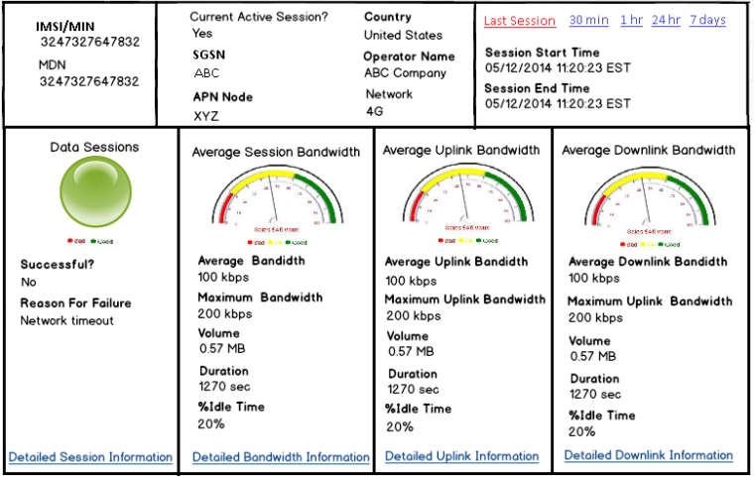

#### 30 min, 1 hr, 24 hr, 7 days

PCS GUI shall have the ability to display the following information, on one page, for a selected IMSI for each of the time intervals (15 min, 1 hr, 24 hr, 7 days) based on the end times of the sessions:

* IMSI/MIN
* MDN
* Last Session Attempt
  + Successful?
  + Failure Reason
  + Session Start Time
  + Network Type – 2G,3G,4G
  + Session Create Time
  + Roaming Country
  + Visited Operator
  + APN Node
  + SGSN
* Data Sessions
  + Visual display of QoE metric (i.e. gauge with thresholds) – based on failure percentage
  + Total Data Session Failures
  + Total Data Session Successes
  + Success Percentage
  + Link to view Detailed Information (section 3.3.2)
* Data Session Activation time
  + Visual display of QoE metric (i.e. gauge with thresholds)
  + Average Session Activation time
  + Maximum Session Activation time
  + Minimum Session Activation time
  + Link to view Detailed Information (section 3.3.3)
* Average Session Bandwidth
  + Visual display of QoE metric (i.e. gauge with thresholds)
  + Average Bandwidth
  + Maximum Bandwidth
  + Volume
  + Duration
  + % Idle Time
  + Link to view Detailed Information (section 3.3.1)
* Average Uplink Bandwidth
  + Visual display of QoE metric (i.e. gauge with thresholds)
  + Average Uplink Bandwidth
  + Maximum Uplink Bandwidth
  + Volume
  + Duration
  + % Idle Time
  + Link to view Detailed Information (section 3.3.1)
* Average Downlink Bandwidth
  + Visual display of QoE metric (i.e. gauge with thresholds)
  + Average Downlink Bandwidth
  + Maximum Downlink Bandwidth
  + Volume
  + Duration
  + % Idle Time
  + Link to view Detailed Information (section 3.3.1)

**Example**:

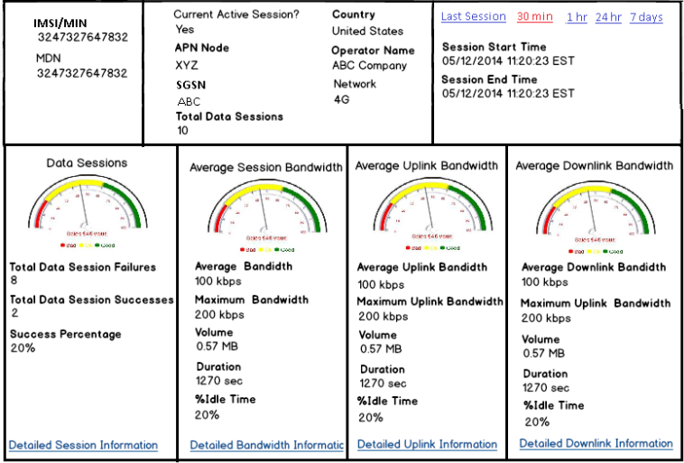

## Service Level Detail View Information

### Bandwidth Reports

The system shall have the ability to display detailed information for the following bandwidth reports for the selected IMSI with a default of the last 7 days:

* Average Bandwidth
* Average Uplink Bandwidth
* Average Downlink Bandwidth

#### Filter By Criteria for Bandwidth Report

PCS GUI shall provide the user with the ability to filter the report by the following

* Start/End Date – up to 12 months
* RAN Type (Radio Access Network)
* APN/Realm
* Their Country
* Their Name

#### Display Trending Information for Bandwidth Report

The system shall have the ability to have a visual display with the trending information for the specified time interval. The default view will be the last 7 days. The trending information shall be aggregated as follows:

* 1 day or less = hourly
* 2 days to 7 days = daily
* Over days to 3 months = weekly
* Over 3 months = monthly

#### Display Data in Table for Bandwidth Report

The system shall have the ability to display the following information in a table that can be exported into a csv file:

* Usage Date and Time
* IMSI/MIN
* MSISDN/MDN
* Their Country
* Their MCC
* Their MNC
* Service Package ID
* Volume (MB)
* Duration
* Aggregated Idle Time (%)
* Uplink Idle Time (%)
* Downlink Idle Time (%)
* Max Bandwidth (kbps)
* Max Uplink Bandwidth (kbps)
* Max Downlink Bandwidth (kbps)
* Average Bandwidth (kbps)
* Average Uplink Bandwidth (kbps)
* Average Downlink Bandwidth (kbps)
* Radio Access Type
* APN/Realm

### Data Session Context Report

The system shall have the ability to generate a Data Session Context Report which displays the trending of PDP Context Sessions for the selected IMSI.

#### Filter By Criteria for Data Session Context Report

The system shall provide the user with the ability filter the report by the following:

* Start/End Date – up to 12 months
* Failures
* Success
* Reason Code
* Roaming Partner Country
* Roaming Partner Name

#### Display Trending Information for Data Session Context Report

The system shall have the ability to have a visual display with the trending information for the specified time interval. The default view will be the last 7 days. The trending information shall be aggregated as follows:

* 1 day or less = hourly
* 2 days to 7 days = daily
* Over days to 3 months = weekly
* Over 3 months = monthly

#### Display Data in Table for Data Session Context Report

The system shall have the ability to display the following information in a table that can be exported into a csv file:

* IMSI
* MSISDN
* Roaming Country
* Visited Network
* Status (Successful, Failed)
* Reason Code
* Network Type
* Duration
* Data Session Start Time
* Data Session End Time
* SGSN
* GGSN
* Session Activation time

### Data Session Activation Time Report

The system shall have the ability to generate a Data Session Context Report which displays the trending of Data Session Activation Time for the selected IMSI.

#### Filter By Criteria for Data Session Activation Time Report

The system shall provide the user with the ability filter the report by the following:

* Start/End Date – up to 12 months
* Roaming Partner Country
* Roaming Partner Name

#### Display Trending Information for Data Session Activation Time Report

The system shall have the ability to have a visual display with the trending information for the specified time interval. The default view will be the last 7 days. The trending information shall be aggregated as follows:

* 1 day or less = hourly
* 2 days to 7 days = daily
* Over days to 3 months = weekly
* Over 3 months = monthly

#### Display Data in Table for Data Session Activation Time Report

The system shall have the ability to display the following information in a table that can be exported into a csv file:

* IMSI
* MSISDN
* Roaming Country
* Visited Network
* Status (Successful, Failed)
* Reason Code
* Network Type
* Duration
* Data Session Start Time
* Data Session End Time
* Session Activation time
* SGSN
* GGSN

### Reports Based on Search Criteria

The system shall have the ability to display the Bandwidth, Data Session Context, and Data Session Activation Time reports for the list of IMSIs that are included in the search results on the Subscriber view of the PCS GUI.

## Enterprise Reporting

### Adhoc Reports by Subject Area

Enterprise Reporting shall provide the user with the ability to create ad hoc reports.

#### Group Action and Subscriber Roaming History

Enterprise Reporting shall create subject areas for Group Action History and Subscriber Roaming History.

##### Group Action History Subject Area Attributes

Enterprise Reporting shall provide the user with the ability to access the following Group Action History subject area attributes:

* Group
* Group ID
* IMSI
* MIN
* Action Type
* Action Timestamp
* Action Content
* Action Description
* Recipient
* Voice Status
* Data Status
* Escalation Alert
* Roaming Country
* Failed Timestamp
* Recipient Name
* Recipient Email Address
* Action Status

##### Subscriber Roaming History Subject Area Attributes

Enterprise Reporting shall provide the user with the ability to access the following Subscriber Roaming History subject area attributes:

* IMSI
* MIN
* Service Type
* Activity Timestamp
* Home Operator Number
* Geo Location Country Code
* Geo Location Operator Number
* Geo Location Node
* Message Type
* Resolution Type
* Resolution Code
* Service Technology
* Insert Timestamp

## PCS Provisioning GUI

### Multiple Template Policies per Group

PCS Provisioning shall have the ability to allow multiple policy templates per group.

#### Provision Templates

PCS Provisioning shall provide the user with the ability to add/delete templates.

##### Adding/Using Templates

PCS Provisioning shall provide the user with the ability to add/use a given template zero to many times within a group.

##### Template Policy Information

PCS Provisioning shall provide the user with the ability to enter the currently existing template policy information for each template added within a group.

##### Deleted Templates

PCS Provisioning shall have the ability to remove all data associated with a template that has been deleted.

##### Display Delete Confirmation Message

PCS Provisioning shall have the ability to display a delete confirmation message to the user when the user chooses to delete a template.

## Rules Engine

### Trigger Notifications

Rules Engine shall have the ability to trigger notifications and other types of custom actions based on the rules criteria. The following are notifications needed:

#### Trigger an email Notification when there are more than XX consecutive Data Session Create failures. The email notification should contain the following information:

* IMSI/MIN
* MSISDN/MDN
* Group Name
* Failure Error Code
* Failure Reason

#### Trigger an email Notification when the Session failure percentage in the last 30 minutes is greater than or equal to the threshold value OR Average B/W in the last 30 minutes is less than or equal to the threshold value OR Session Activation time in the last 30 minutes is greater than or equal to the threshold value. The email notifications should contain the following information:

* IMSI/MIN
* MSISDN/MDN
* Group Name
* # of Data Sessions
* Start and End time
* Session Failure Percentage
* Average B/W
* Session Activation time

#### Trigger an email Notification when the Session failure percentage in the last 30 minutes is greater than or equal to the threshold value OR Average B/W for APN Node XXX in the last 30 minutes is less than or equal to the threshold value OR Session Activation time in the last 30 minutes is greater than or equal to the threshold value. The email notifications should contain the following information:

* IMSI/MIN
* MSISDN/MDN
* Group Name
* APN Node
* # of Data Sessions
* Start and End time
* Session Failure Percentage
* Average B/W
* Session Activation time

#### Trigger an email Notification when the overall Data QOE status based on the last 30 minutes interval is RED. The email notifications should contain the following information:

* IMSI/MIN
* MSISDN/MDN
* Group Name
* # of Data Sessions
* Start and End time
* Session Failure Percentage
* Average B/W
* Session Activation time

#### Trigger an email Notification when the last session Average B/W for the last session for APN Node XXX and Network Type equal to XX is less than or equal to the threshold value OR Average B/W for the last session for APN Node XXX and Network Type equal to YY is less than or equal to the threshold value. The email notifications should contain the following information:

* IMSI/MIN
* MSISDN/MDN
* Group Name
* APN Node
* Network Type
* Session Start Time
* Session End time
* Average B/W
* Session Activation time

#### Trigger an email Notification if the last session has a failed. The email notifications should contain the following information:

* IMSI/MIN
* MSISDN/MDN
* Group Name
* Failure Time Stamp
* Roaming Country
* Reason for Failure

### Rules Template Attributes

The Rules template will have access to the following attributes:

* IMSI
* MSISDN
* Roaming Country
* Visited Network
* Status (Successful, Failed)
* Reason Code
* Network Type
* Duration
* Data Session Start Time
* Data Session End Time
* SGSN
* GGSN
* Session Activation time
* Time Interval
* APN Node
* Network Type
* Group Name
* Max Bandwidth (kbps)
* Max Uplink Bandwidth (kbps)
* Max Downlink Bandwidth (kbps)
* Average Bandwidth (kbps)
* Average Uplink Bandwidth (kbps)
* Average Downlink Bandwidth (kbps)
* Overall Data QOE Status based on the 30 min time interval
* CSP Subscriber Attributes

### Suppression of Notifications

Rules Engine shall have the ability to suppress alerts from being sent on a per template level.

### Group Status Notification

The Group Summary Status Notification should add the following information to the email body. The information shall be appended to the email content defined in PCS 2.0 release.

* Total Number of Data Sessions since the last Group Status Notification
* Data Session Create Failures as a percentage since the last Group Status Notification

**Example:**

Data Sessions since 10/12/2014 10:00 a.m. EST

Total Data Sessions..20

Total Data Session Create Failures..10          50%

### Logging, Reporting, and Audits

Data QoE actions will emulate the existing behavior around tracking notifications around quality templates.

## Billling

Actions created out of the new templates will be billed just like the existing templates.

## Crossroads

### Left Menu Item

Crossroads shall create a new left menu item called **“Analyzer PCS Reporting”** which shall be displayed under the group name “Premium Customer Service” at the same level as “Monitor my Subscribers” on the “Subscriber” tab.

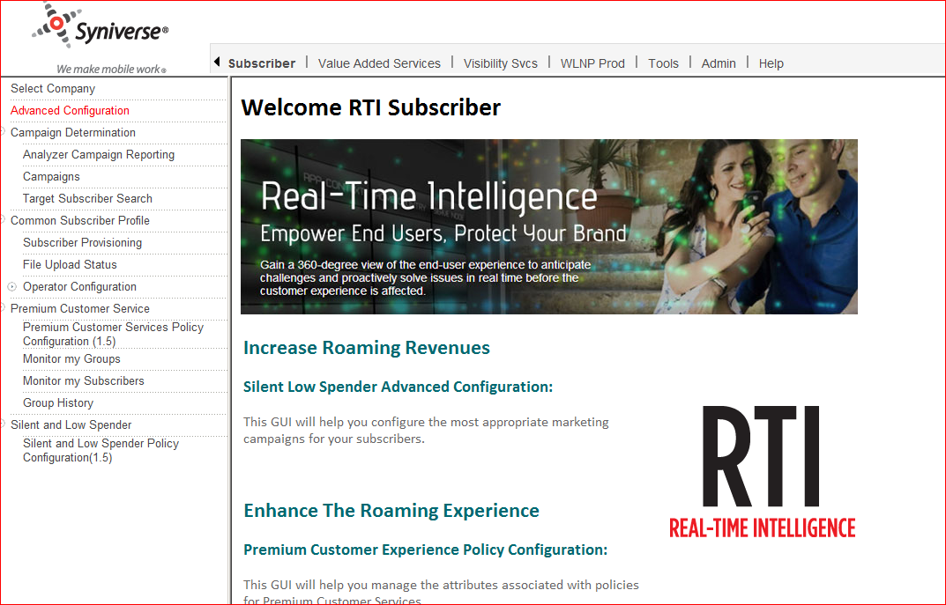

### User Level Permissions

Crossroads shall create the following new user level permissions under the group permission name “Subscriber – Premium Customer Service” which will be available for provisioning to users who have the “Premium Customer Service GUI” company level permission:

* Service Level View – provides access to “Monitor my Subscriber” link and the Service Level View tab within that page
* Analyzer PCS Reporting – controls the “Analyzer PCS Reporting” link

# Supplemental Requirements: (Reference Section 1.4 and Section 3)

# Requirements Tracing Matrix

| Traceability Map  Premium Customer Services (PCS) 2.5  <Link to approved Requirements Document> | | |
| --- | --- | --- |
| For <Asset or Team> | | |
| High Level Design | Detail Level Design | System Test Plan |
| <Link to HLD> | <Link to DLD> | <Link to System Test Plan> |

| Requirement  # | Requirement title | Asset/Team | HLD  # | DLD  # | Test  # | Comment |
| --- | --- | --- | --- | --- | --- | --- |
| 3 | FEATURE REQUIREMENTS |  |  |  |  |  |
|  |  |  |  |  |  |  |
|  |  |  |  |  |  |  |
|  |  |  |  |  |  |  |